Bucket Report

1. 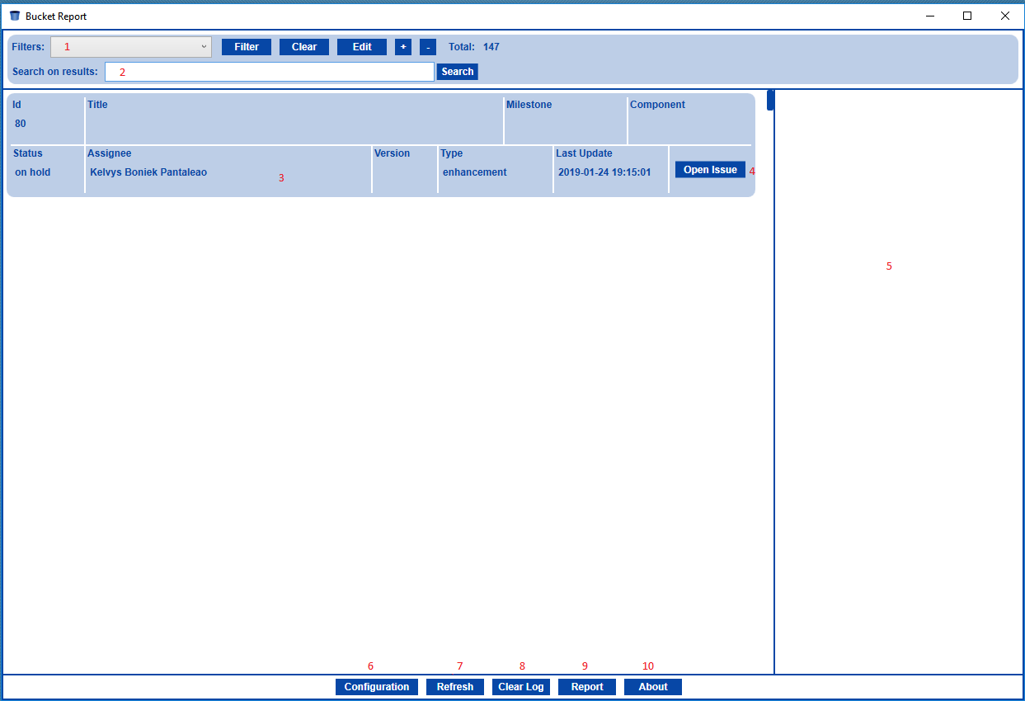Main window:
   1. Filters list.
   2. Quick search on results.
   3. Filtered Issues.
   4. Open issue on default browser.
   5. Event log.
   6. Open configuration (see item 2).
   7. Refresh issues from Bitbucket.
   8. Clear even log.
   9. Open report window (see item 4)
   10. Open about window.
2. 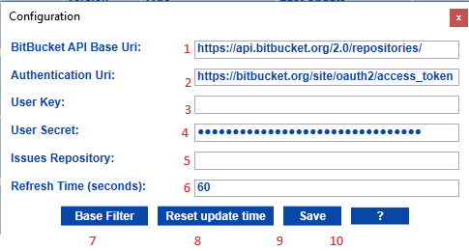Configuration window:
   1. Bitbucket base repositories API url (Default).
   2. Authentication url (Default).
   3. Bitbucket user key (see item 2.10).
   4. Bitbucket user secret (see item 2.10).
   5. Issues repository url fragment: Ex.: ‘project/repository_name/issues’.
   6. Refresh time in seconds.
   7. Base filter, use this filter to pre-filter the issues from remote repository.
   8. Reset the update time, use this to refresh the entire local repository.
   9. Save changes.
   10. Help, about user key and secret:

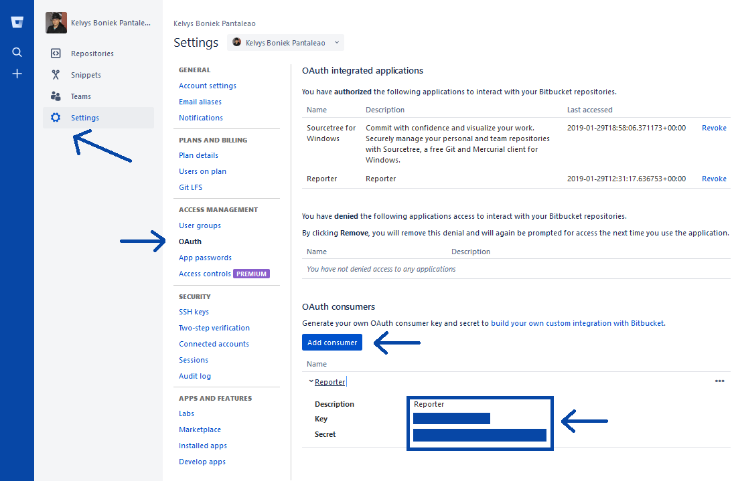

1. 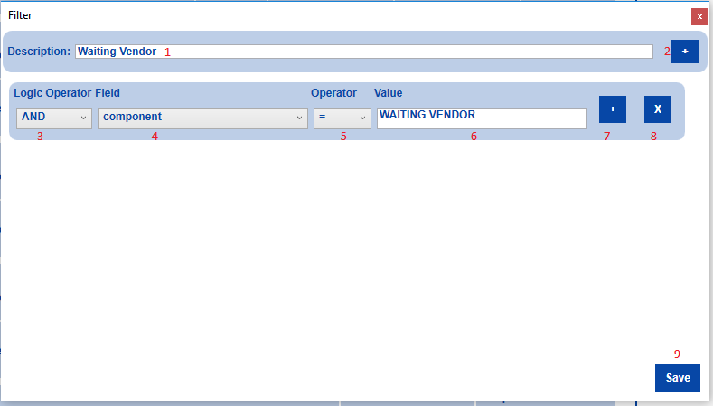Filter window:
   1. Filter description.
   2. Add filter.
   3. Logic operator, can be ’AND’ or ‘OR’.
   4. Field to filter.
   5. Operator:
      1. ‘=’ Equals.
      2. ‘!=’ Not Equal.
      3. ‘>’ Greater than.
      4. ‘<’ Less than.
      5. ‘>=’ Greater than or equal.
      6. ‘<=’ Less than or equal.
      7. ‘~’ text contains;
      8. ‘!~’ text not contains.
   6. Value to be filtered.
   7. Add sub filter, can be used to complex filtering.
   8. Remove filter.
   9. Save changes.
2. 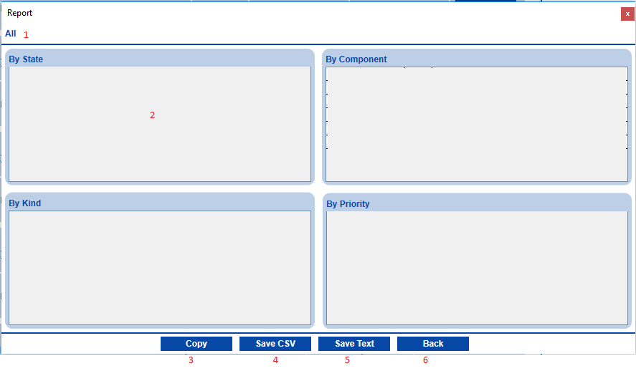Report window:
   1. Selected filter.
   2. Views.
   3. Copy views resume into clipboard.
   4. Save filtered results in CSV file.
   5. Save resume in txt file.
   6. Back.